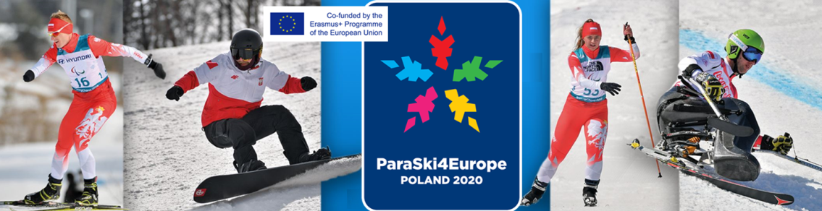
Poland – Czarna Gora Ski Resort; Jamrozowa Polana , Duszniki Biathlon Centre
24 February – 2 March 2020

F I R S T E N T R Y F O R M

ORGANISATION:
TEAM CONTACT PERSON:
EMAIL:
PHONE:

ATHLETES AGE: from 12 y/o to – no limit

NATIONAL /INTERNATIONAL SPORTS LICENCE are required

MEDICAL CLASSIFICATION – National or International medical classification for intermediate athletes are required . Athletes without classification will be initially classified during the competition and, based on this classification, will be assigned to the higher by one start class.

Each NPC must ensure that all the members of their delegation are appropriately insured, including coverage for travel, liability and accidents. All delegation members must have appropriate accident and health insurance in order to race in international ski competitions.

No. of ATHLETES; please insert the expected number of athletes including B class guides: MINIMUM quota in team per all 4 sports : 2 athletes
PARA ALPINE SKIING | PARA-SNOWBOARD | PARA CROSS-COUNTRY | PARA-BIATHLON
Draft programme below / Final programme will be announced after receiving First Entry.
SL/GS | GS | Middle distance classic and free Team relay | Middle distance
Total  Athletes/Guides : | Total Athletes : | Total  Athletes/Guides : | Total  Athletes /Guides:
TOTAL ATHLETS/GUIDES : INCLUDING No of wheelchair users :
Final programme will be announced after receiving First Entry

STAFF: MAXIMUM NUMBER OF STAFF:

For teams 2 - 4 athletes: 2
For teams 5 -8: 3
For teams 9 -12: 5
For teams 12 and more: 6

Team leader / Coaches | Technical staff | Escorts/others | TOTAL

Guides of visually impaired skiers have the athlete’s status.

Extra staff will be accepted for the additional charge but the organizer may increase the number of staff free of charge in special cases. The organizer reserves the right to make the decision to accept the final number of athletes and staff.

TOTAL Nº . of TEAM:

TRANSPORT:

The HOC provides transport services from/to Wroclaw Airport/ Wroclaw railway station.

We could offer also transport service for extra payment from/to Prague, Berlin Airports. Details and extra payment will be determined individually.

PREVISION OF ARRIVAL & DEPARTURE:

Date of arrival:
Date of departure:
By airplane : Airport/City :
By car (yes / no)
By train (yes / no)
Extra transport (from: )

Extra days will be accepted for the additional charge

Additional information

TO BE RETURNED: December 31th, 2019
e-mail: wintergames@paralympic.org.pl

Final entry forms with detailed programme will be delivered at the end of December
Polski Komitet Paraolimpijski - Polish Paralympic Committee
ul.Trylogii 2/16 , 01-982 Warszawa, POLAND
http://paralympic.org.pl/ phone: +48 602614892; wintergames@paralympic.org.pl

